**Switzerland Certificate Attestation Services in the UAE**

Switzerland certificate [**attestation services in abu dhabi**](https://attestglobal.com/) is a critical process for individuals and businesses looking to use Swiss-issued documents in the UAE. Whether for employment, education, visa applications, or business purposes, attestation ensures that your documents are officially recognized and accepted by UAE authorities. This article delves into the importance of attestation, the types of documents covered, and how professional [**attestation services in abu dhabi**](https://attestglobal.com/) can simplify the process.

**Importance of Certificate Attestation**

The UAE has stringent regulations for document authentication to maintain legal and procedural transparency. Attestation verifies that a certificate issued in Switzerland is genuine and valid for use in the UAE. Without proper attestation, documents may not be accepted by government bodies, educational institutions, or employers, leading to delays in processing applications.

**The Switzerland Certificate Attestation Process**

The process involves multiple steps to ensure the authenticity and validity of the document. Below is a simplified breakdown:

1. **Notary Verification**:
   * The document is verified and stamped by a Swiss notary to confirm its authenticity.
2. **State Authority Authentication**:
   * The respective cantonal or state authority in Switzerland authenticates the document.
3. **Swiss Ministry of Foreign Affairs**:
   * The Swiss Federal Department of Foreign Affairs (FDFA) certifies the document.
4. **UAE Embassy in Switzerland**:
   * The UAE embassy or consulate in Switzerland provides the attestation stamp, making the document valid for use in the UAE.
5. **MOFA Attestation in UAE**:
   * The final attestation is performed by the UAE Ministry of Foreign Affairs to complete the legalization process.

Prime global attestation is the uae no.1 attestation company that offer [**Attestation services in Abu Dhabi**](https://www.attestglobal.com)**,** [**Attestation services in UAE**](https://www.attestglobal.com/)**,** [**Attestation services in Dubai**](https://www.attestglobal.com)**,** [**attestation services in sharjah**](https://www.attestglobal.com). We offer attestation for degree, diploma, marriage, birth, mofa, tc and commercial documents attestation in uae over 100+ countries at best prices.

**Prime Global Attestation: Your Trusted Partner**

For reliable Switzerland certificate attestation services in the UAE, **Prime Global Attestation** is a leading choice. Their expert team ensures a hassle-free process, keeping clients informed at every step. With their commitment to accuracy, timeliness, and transparency, you can focus on your goals while they handle the paperwork.

**Conclusion**

Switzerland certificate [**attestation services in abu dhabi**](https://attestglobal.com/) is essential for anyone seeking to use Swiss documents in the UAE. Whether for personal or professional needs, understanding the process and relying on trusted attestation services can save time and effort. Choose a professional partner like Prime Global Attestation to make the process smooth, efficient, and stress-free.

For more details information, [**Attestation services in Abu Dhabi**](https://www.attestglobal.com)**,** [**Attestation services in UAE**](https://www.attestglobal.com/)**,** [**Attestation services in Dubai**](https://www.attestglobal.com)**,** [**attestation services in sharjah**](https://www.attestglobal.com)

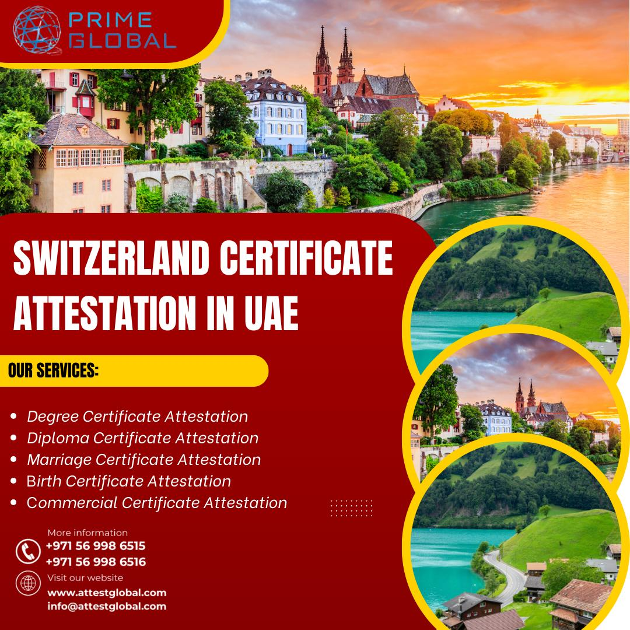Top of Form

Bottom of Form